# Photo-Share – Web Application Investigation

## Requirements List

### Functional

|  |  |  |
| --- | --- | --- |
| Requirement | MOSCOW Rule | Test |
| Public user be able to View photographer profiles | Must have | Profiles visible when no log in |
| Public users be able to view photos | Must have | Photos visible with no log in |
| Public user be able to search photos | Must have | Search returns requested photos with no log in |
| Public user able to register as shopper/Photographer | Must Have | Register takes user to registration form |
| Public user able to create shopper profile | Must have | Shopper registration creates shopper profile |
| Public user able to create photographer profile | Must have | Photographer registration creates photographer profile |
| Shopper be able to log in | Must Have | Login enables shopper functions |
| Shopper can Buy Photos | Should have | Buy photos takes user to purchase page |
| Photographer be able to log in | Must have | Photographer log in enables photographer functions |
| Photographer be able to upload Photos | Must have | Upload photo adds photo to user profile |
| Photographer able to add meta data / set price of photo | Could have | Meta data / price change saved to data base |
| Photographer able to enter chat | Should have | Chat function available after photographer log in |
| Admin able to approve photographer | Must have | Photographer able to log in after approval |
| Admin able to moderate chat page | Should have | Chat changes made after admin edit/delete |
| Admin can ban users from chat | Could Have | User unable to enter chat after ban |

### Non-Functional

* Web site must secure all data
* Website must load reliably
* Website should load within 500 milliseconds and 3 seconds
* Cross browser compatibility
* Website to meet W3C standards
* Website will support various screen sizes and resolutions.
* User passwords will be stored securely using sha512 hashing.
* User friendly interface represented in a GUI

## System Use Case Diagrams

### Public

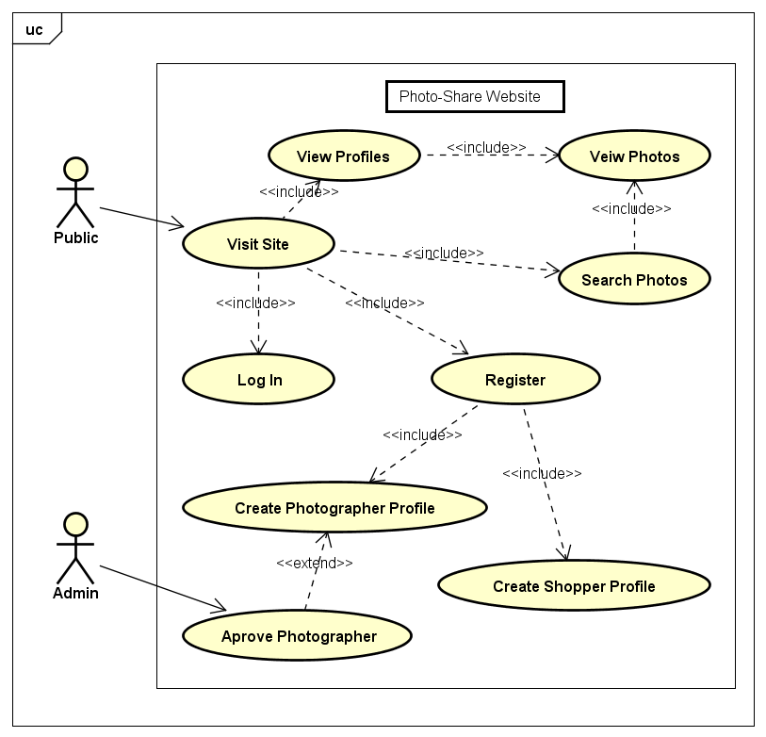

### Shopper

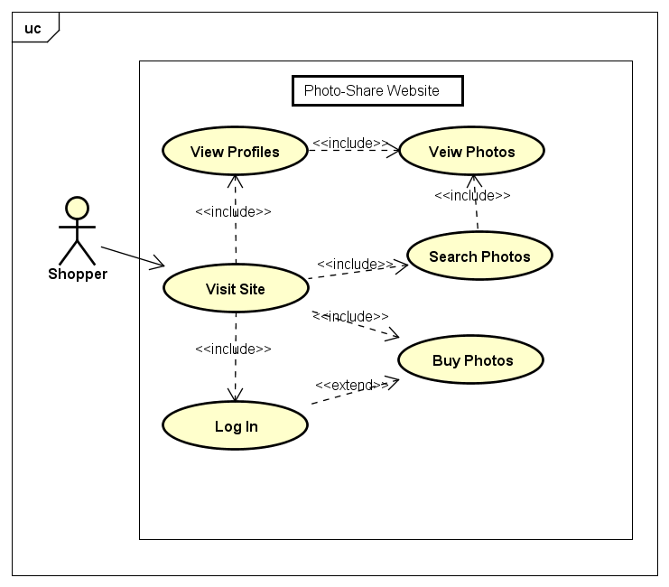

### Photographer

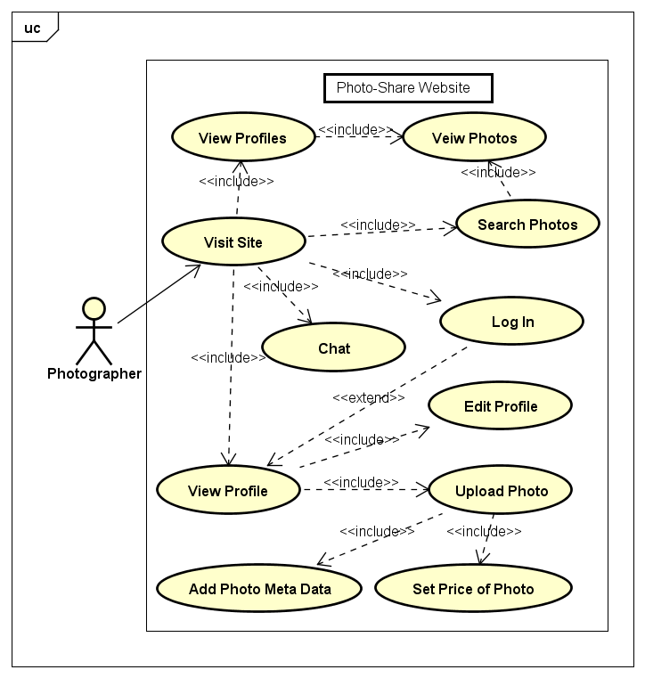

### Administrator

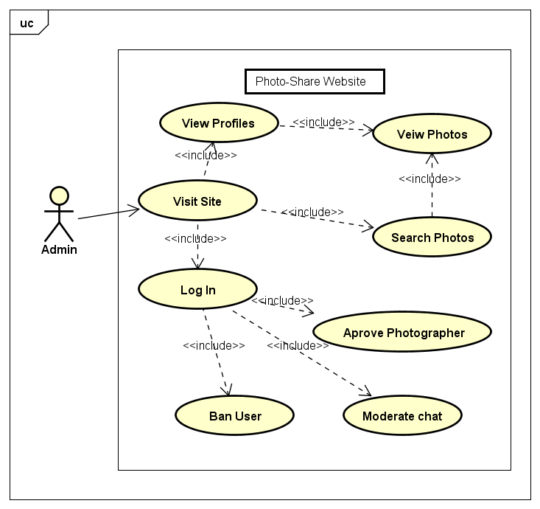

## Website Structure Diagram

## 

## Page Justification

### Home Page

#### Description

The home page will present the user with a slide show of photos from the site, along with links in the header/footer to the sites main pages and functionality depending on the login state and type of the user.

#### Justification

The purpose of the welcome page is to introduce the user to the sites main purpose (photo sharing site) and to enable the user to access the rest of the sites functionality:

* Login
* Registration
* Search Photos
* View Profiles

### Log in Page

#### Description

The Login page will display a basic login form with user and password fields, login button and a cancel button along with links in the header/footer to the sites main pages and functionality depending on the login state and type of the user.

#### Justification

The purpose of the login page is to allow users of the site to login and for their login details to be verified by the site.

### Create Profile Page

#### Description

The create profile page will display a web form to the user with details to be completed depending on the type of profile selected on the form by the user (shopper/photographer), along with submit and cancel buttons. Along with links in the header/footer to the sites main pages and functionality depending on the login state and type of the user.

#### Justification

The purpose of the registration page is to allow the user to input all the necessary personal details in order to become either a registered shopper or photographer on the site.

### Search Page

#### Description

The search page will contain a side bar for search options, a bar for search data input, a search results panel and links in the header/footer to the sites main pages and functionality depending on the login state and type of the user.

#### Justification

The purpose of the search page is to display the results of searches to the user based on the following filters:

* Search photo by title
* Search photo by photographer
* Search photo by price

### Photographers Page

#### Description

The photographers page will display a list of the details of all the current photographers registered with the site, with a link to each profile page. Along with links in the header/footer to the sites main pages and functionality depending on the login state and type of the user.

#### Justification

The purpose of the photographer’s page is to allow the user to view all the current photographers of the site, and to navigate to the profiles.

### Profile Page

#### Description

The profile page with display the details and photograph listing of the currently selected photographer. Further options to upload photos and add meta data to photos will be available if the photographer is logged in. Along with links in the header/footer to the sites main pages and functionality depending on the login state and type of the user.

#### Justification

The purpose of the profile page is to provide the user with the photographers details along with a list of current photos. Additionally, photographers are able to upload photos and add meta data to photos.

### Photograph Page

#### Description

The Photograph page will display the selected photograph to the user, display options to purchase if shopper logged in. Along with links in the header/footer to the sites main pages and functionality depending on the login state and type of the user.

#### Justification

The photograph page enables the user to view the photographs and if allowed purchase the photo.

### Purchase Page

#### Description

The purchase page will present the user with a form to enter payment/paypal details to purchase the selected photo.

#### Justification

This page enables the shopper to transfer funds to the photographer for the photo to be purchased.

### Chat Page

#### Description

The chat page with present the user with a chat room. Along with links in the header/footer to the sites main pages and functionality depending on the login state and type of the user.

#### Justification

The chat page will enable any logged in photographer to chat with other photographers who are present on the chat page. Additionally, the chat page will enable the admin to edit/delete comments as required.

### Admin Page

#### Description

The Admin page will present the admin with a list of all current shoppers and photographers of the site, with options to approve/ban photographers, a link to chat page and links in the header/footer to the sites main pages and functionality depending on the login state and type of the user.

#### Justification

The admin page allows the admin to approve photographer profiles, ban users from chat if necessary and monitor chat page through a link.